Reading at home is very important. Learners who read frequently at home, tend to progress well in school. We would like to make reading more fun and to inspire learners to take ownership of their reading, whilst developing lifelong skills. Please see examples below of how to set our your new Home Reading Journal. You may include pictures or drawings as frequently as you would like.

15/08/17 I have loved reading ‘Not So
Text: Not So Far Away’! I felt as though
Far Away. I was in a magical land. Reading on the beach
was so relaxing. My favourite part was when King Triton burst out of the sea!

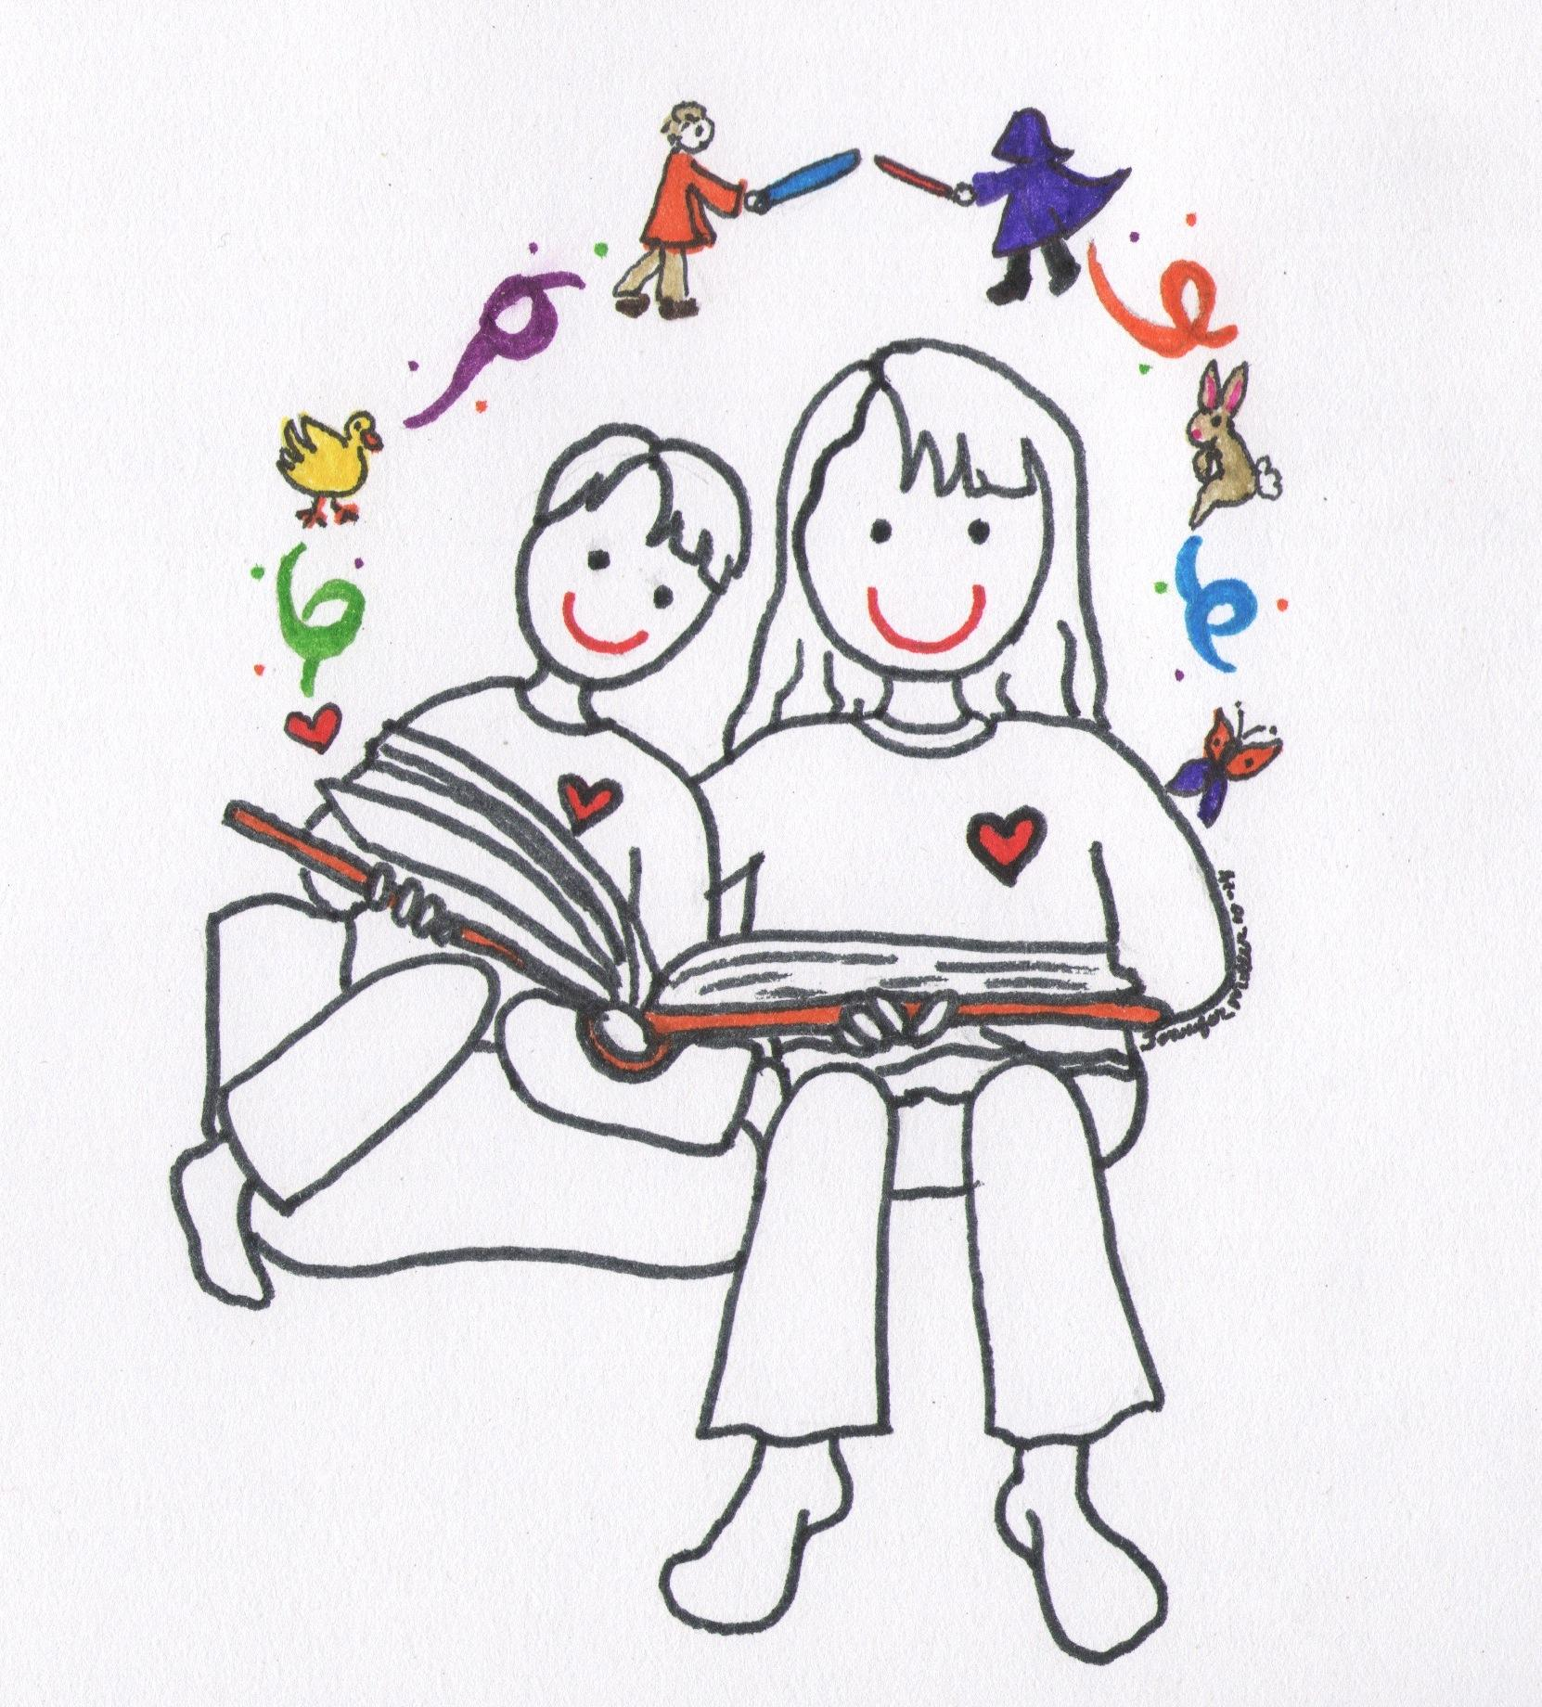
19/08/17
Text: The Tale This was one of my favourite books as a child and I enjoyed
of Peter reading the story to my nephew. We talked about what an
Rabbit author and illustrator do and my nephew thought the
illustrations were fantastic!

20/08/17 I have learnt a fact about tractors. They need very large tyres to pull heavy
Text: Transport equipment. I found the words ‘equipment’ and ‘fields’ difficult to read but I tried
my very best to sound them out.

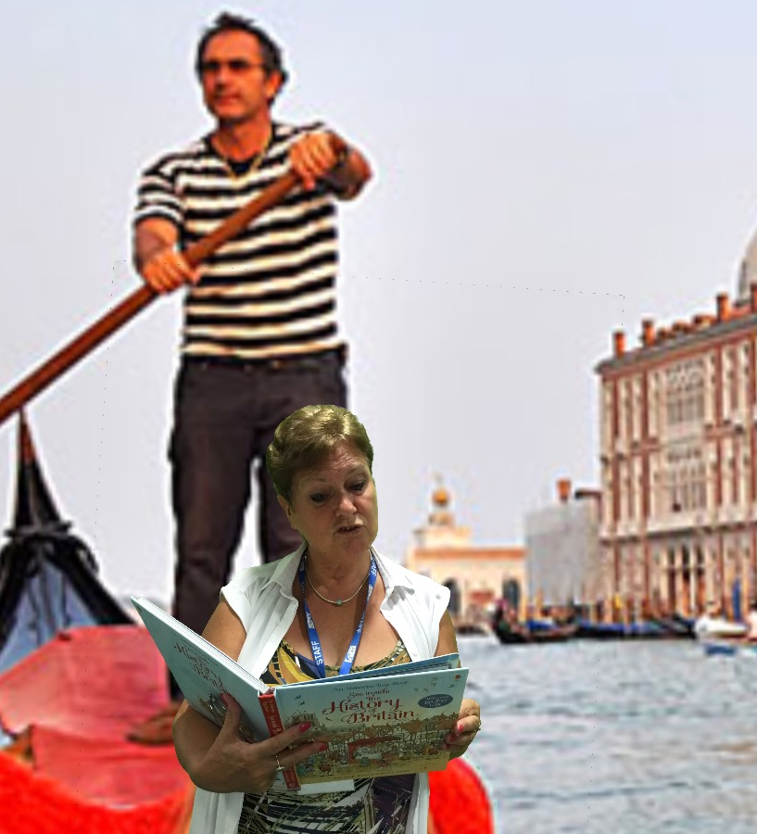
24/08/17
Text: The I taught my gondola driver all about the History of Britain. History of He loved learning so many new facts and It was a great Britain opportunity for me to learn some things myself too!

30/08/17
Text: The I have loved reading all about King
Egyptian Tut whilst visiting the pyramids. I
Echo found out that over 130 pyramids have
been discovered!

